**CHANDRIKA WOMEN AND YOUTH FOUNDATION**



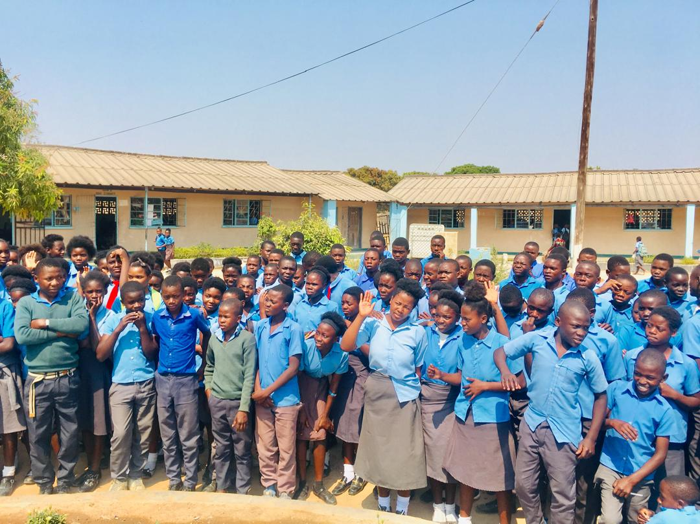

**MUCHINKA PRIMARY SCHOOL CLIMATE CHANGE SENSITISATION REPORT**

**Introduction**

This activity report is based on a Climate Change sensitization and tree planting that was conducted on the 1st of October 2024, which was held at Muchinka Combined School under the Primary section.

**Objective**

To raise awareness among young girls and boys about climate change and to inspire eco-friendly habits and practices that promote environmental sustainability.

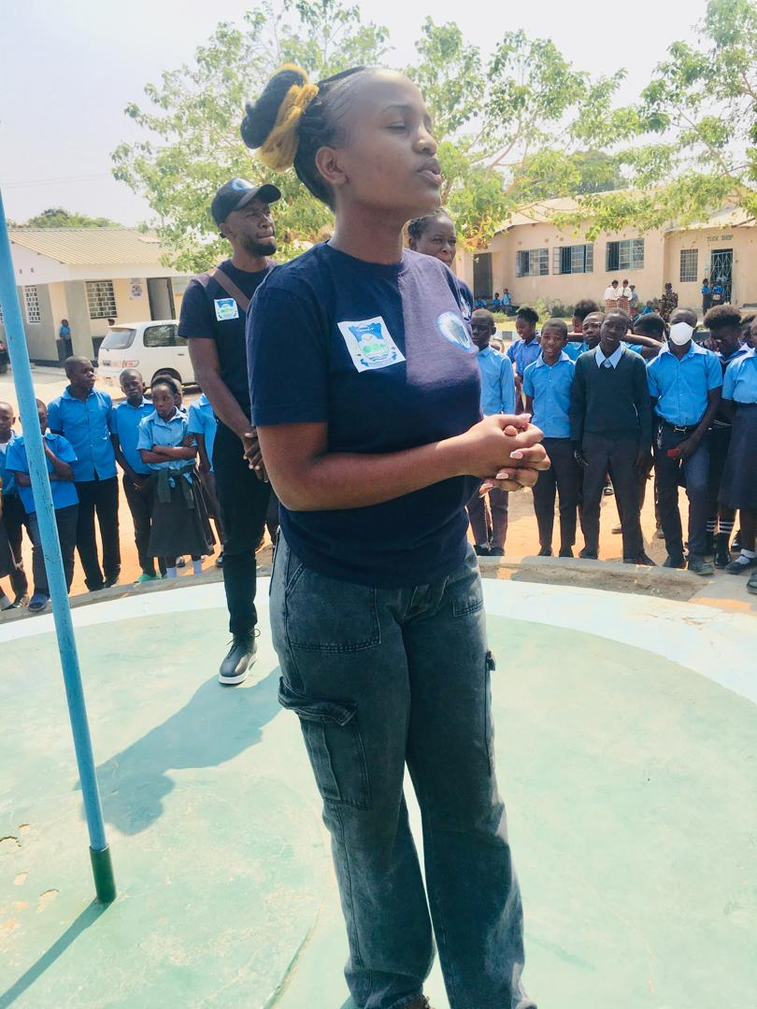**Welcoming Remarks**

***One of Youth Facilitators giving an overview of Chandrika WYF***

To commence the program, welcoming remarks were given and introductions were made. Thereafter, a brief overview of the organisation was given.

Chandrika Women and Youth Foundation is dedicated to work with young people, children and women in its programs which include: protecting the vulnerable people from bad social vices, providing support to people infected and affected by the HIV/AIDS Pandemic, identifying sports talent in young people, providing community service, empowerment for women, youths and children, providing livelihood skills to women and youths, advocating for gender equality, human rights and governance through information sharing.

**Definition of Climate Change**

***The Facilitator introducing Climate Change***

A question was posed: “What is climate change?” Most pupils were familiar with the term but struggled to express themselves.

Climate change refers to a change in the weather pattern, simply put, when the earth’s weather gets warmer and warmer over time. A good example is what we’re feeling right now. It is abnormally hot. This is all because of Climate Change.

Examples of how we, intentionally and unintentionally contribute to climate change:

1. Using plastic bags for packing lunch or snacks
2. Using electronic devices for long periods of time without breaks
3. Participating in deforestation (tree cutting)
4. Not turning off lights or computers when not in use
5. Using transportation with high carbon emissions
6. Wasting paper or other school supplies
7. Not recycling or properly disposing of trash

After being introduced to climate change, the pupils were asked to define it and share what they had learned. One pupil provided a clear definition and then the grade 7s were encouraged to dive deeper into the topic, as it will be important for their final exams.

**Effects of Climate Change**

***The Facilitator discussing the effects of Climate Change***

Pupils were the asked to mention some of the effects of Climate Change and below was the feedback given;

1. Low water levels in our Kariba Dam leading to back-to-back load shedding (power outages)
2. Really hot summers - like the one we’re experiencing
3. Really cold winters – like the one we just concluded
4. Super strong wind - you can almost get blown away if you’re not careful
5. Water scarcity - there is a water crisis
6. Changes in seasons - it’s supposed to just be hot this month but it’s coupled with wind as if it’s August
7. Rising sea levels - the water at Samfya beach gets too high and dangerous for young children

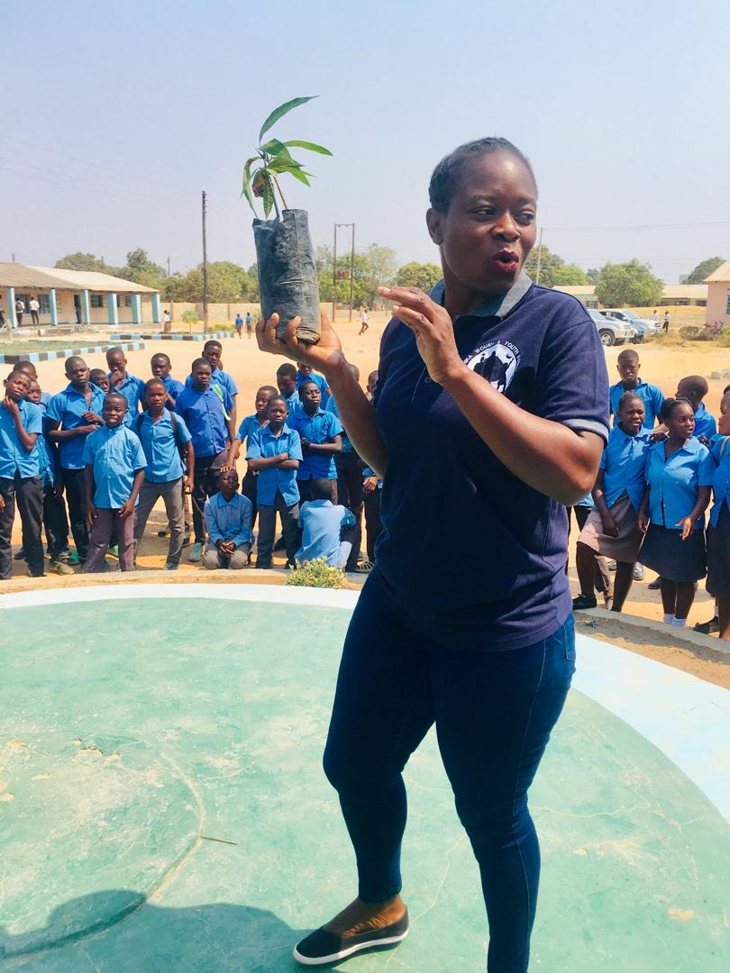**Advantages of Combating Climate Change**

***The Facilitator showing how Climate Change can be combated***

**T**he air will be cleaner and healthier to breathe – increasing our energy levels resulting in more energy to play, learn and participate in activities

1. We’ll have more control over our energy and not rely on fossil fuels – solar and wind power are abundant
2. Our animals, plants and the earth’s natural systems will be protected – preservation of biodiversity and improved human health
3. More people will be encouraged to think long-term and be more responsible
4. Countries will be brought together to work towards a common goal
5. All this will ensure a happy, healthy future for us all – less stress, increased resilience, improved overall well-being, stronger relationships etc.

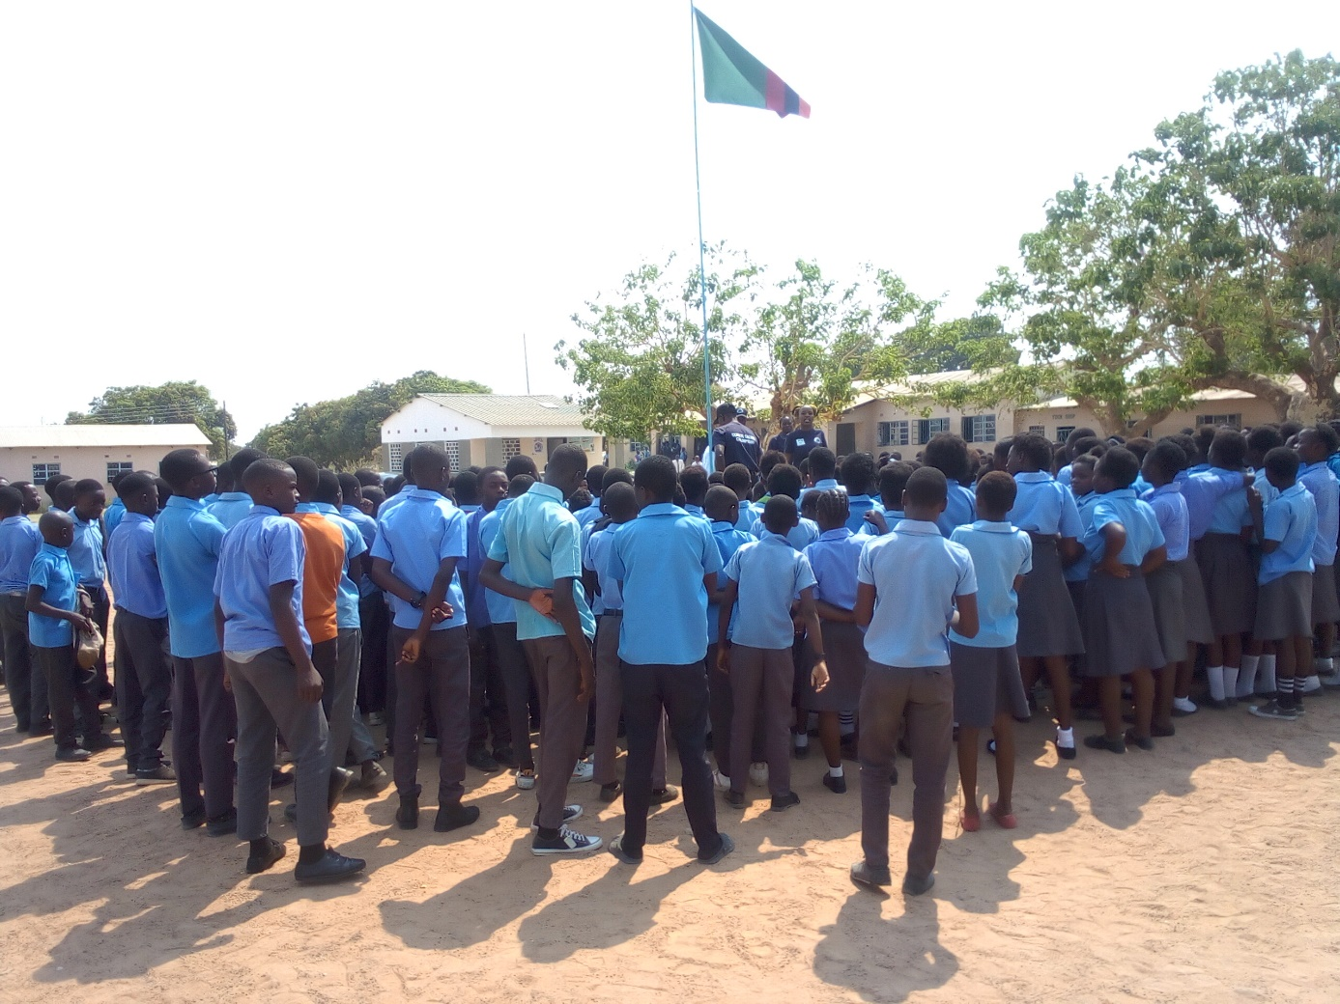***Pupils listening during the sensitization***

**Seedling Orientation and Tree Handover**

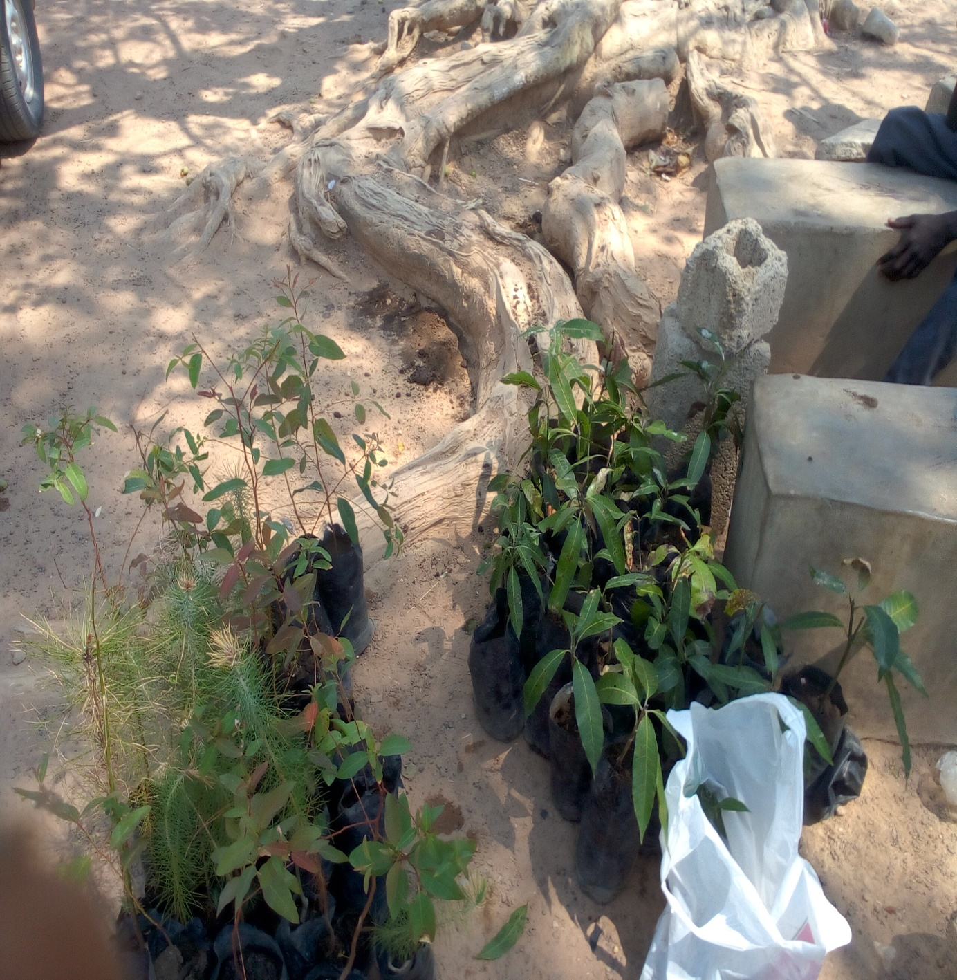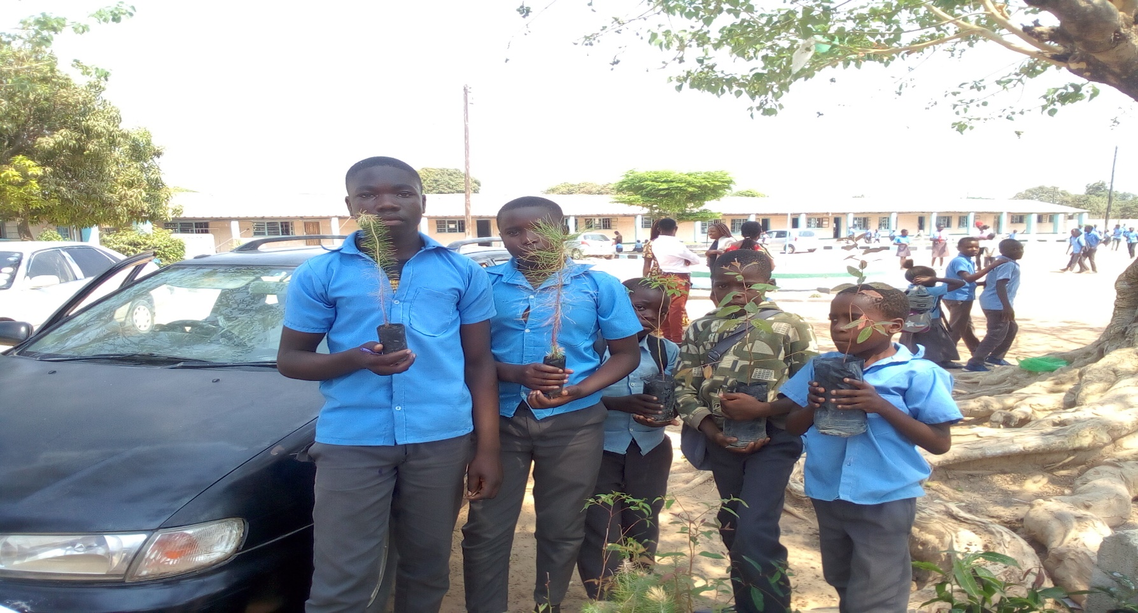

After conducting the sensitization the Executive Director, officially handed over the tree plants to the School Manager and later on, some trees were planted at the school.

**Vote of Thanks by the School Manager**

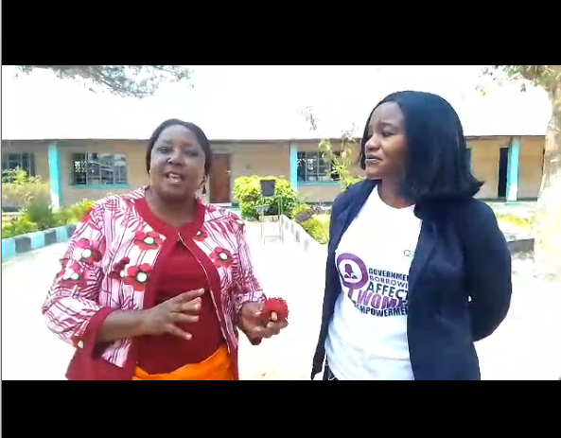Upon receiving the tree plants, the School Manager appreciated Chandrika WYF for their effort in reducing Climate Change issues and also requested the organization to continue conducting sensitizations on Climate Change including other issues such as teenage pregnancy, early / child marriages and drug / substance abuse.

***The School Manager appreciating Chandrika WYF***

The School Manager further went on to state that; “We’d like to appreciate the organisation for the plants received here today. As a school initially, we are also interested in climate change. As you are aware that our country is one of those affected by climate change. When you look at the rain pattern now, for the 2023 – 2024 season, they were really bad.” So as a school we also took an initiative, we have a small portion of land behind our school, where we planted 100 of these plants. They should be 30 by now, some were stolen by mischievous members of our community, but we believe to say that even if they steal, some will be left behind. So we are so appreciative for the fruit trees brought by CWYF, they will go a long way.” - Muchinka Primary School Head Mistress.

**Tree Planting Exercise**

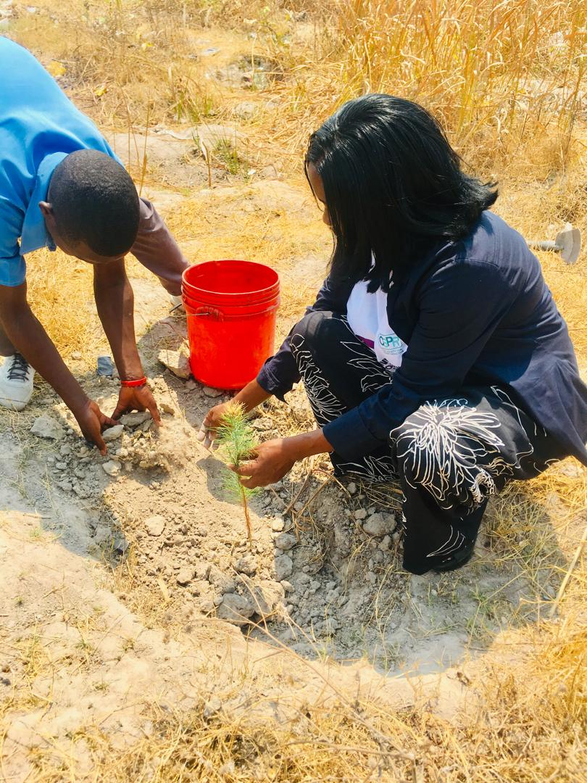A total of 80 trees were planted. With every tree planted, we come one step closer to creating a safer, habitable planet for ourselves and future generations to live and thrive in.

***The School Manager and ED for Chandrika WYF participated in the tree planting Exercise***

**Conclusion**

Educating young children about climate change is crucial for creating a sustainable future. The program not only raised awareness but also inspired the pupils to take action to reduce their carbon footprint and promote sustainability in their lives. As Chandrika Women and Youth Foundation we are confident that the pupils will carry forward the lessons learnt from this program and become climate change champions in their own right.